Public Open House October 24, 2018
Two Hills Senior’s Centre 6:45 PM
ALBERTA ENVIRONMENT AND PARKS

VERMILION RIVER HYDRAULIC AND OPERATION STUDY

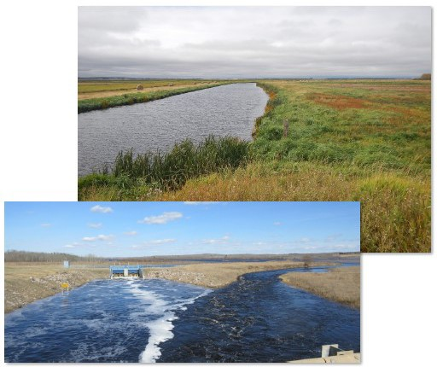

ALSO A PRESENTATION WILL BE GIVEN BY COUNTY OF TWO HILLS MUNICIPAL CONSERVATION COORDINATOR ON
ENVIRONMENTAL FARM PLANS AND AVAILABLE FUNDING PROGRAMS (CAP, ETC.)

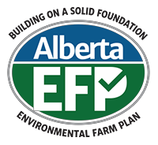

EVERYONE IS WELCOME TO ATTEND

